TFL HURRICANES
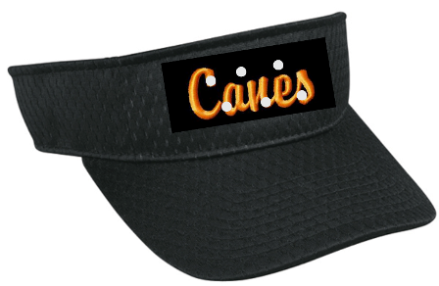 | $18.00 | Black Visor – Script ‘Canes’ with Scattered Crystals 2 1/4" Crown  - Polyester Jersey Mesh  - Pre-curved Visor  - (B) Adjustable Hook/Loop Tape Closure | Visor ______  Subtotal $________
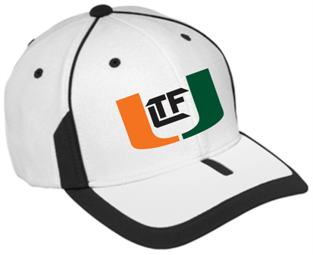 | $20.00  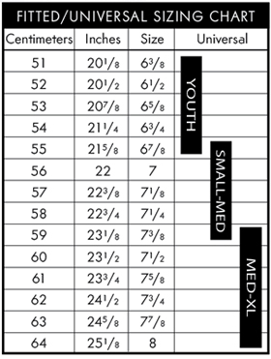 | Sideline Cap – White/Black – Embroidered TFL Hurricanes Logo  Profile/Material: Low profile shape with M2 performance fabric that wicks moisture and heat away  Crown: 2-tone panels with contrasting stitching and contrasting seam tape printing  Visor: PE visor board with contrasting binding  Closure: Universal Fit  Sizes: Youth, S/M, L/XL (Refer to Sizing Chart) | Sideline Cap  Youth _____  S/M _______  L/XL ______  Subtotal $________
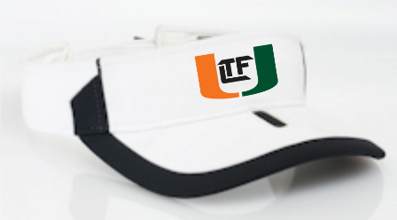 | $18.00 | Sideline Visor – White/Black – Embroidered TFL Hurricanes Logo  Profile/Material: Low profile M2 Performance fabric that wicks moisture and heat away  Crown: 2 inch low profile 2 tone panels  Visor: PE visor board (Pre curved) with contrasting binding and insert  Velcro closure – one size fits all | Sideline Visor _____  Subtotal $________
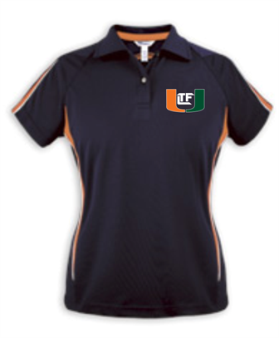 | (S-XL) - $40.00  2XL – add $2.00 | Ladies Moisture Management Polo – Black/Orange – TFL Hurricanes Logo Embroidered on Left Chest  100% micro polyester ottoman polo is specially treated with hi cool technology that will keep you dry and comfortable for the life of the garment. Carefully crafted workmanship allows for the arched color block design on the back, down the sides and front to run parallel with flat piping for added detail and mesh inserts under arm. Self-fabric collar lays flat with collar stays, finished with crystal buttons. | Ladies Phenom  __ Small  __ Medium  __ Large  __ XL  __ 2XL (add 2.00)  Subtotal $________
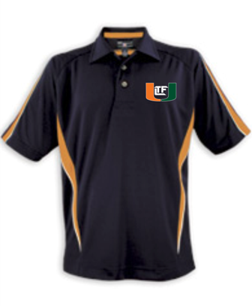 | (S-XL) - $45.00  2XL – add $2.00  3XL – add $4.00 | Men’s Moisture Management Polo – Black/Orange – TFL Hurricanes Logo Embroidered on Left Chest  100% micro polyester ottoman polo is specially treated with hi cool technology that will keep you dry and comfortable for the life of the garment. Carefully crafted workmanship allows for the arched color block design on the back, down the sides and front to run parallel with flat piping for added detail and mesh inserts under arm. Self-fabric collar lays flat with collar stays, finished with crystal buttons. | Men’s Phenom  __ Small  __ Medium  __ Large  __ XL  __ 2XL (add $2.00)  __ 3XL (add $4.00)  Subtotal $________
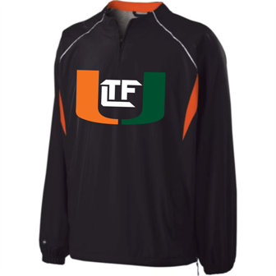 | S-XL $50  2xl $54 | Destroyer Pullover – Black/Orange/White – TFL Hurricanes Logo on Full Front in Tackle Twill  - Micron™ polyester shell is lightweight, wind/water-resistant and quiet for comfortable movement  - Heather grey jersey and nylon lining  - Raglan sleeves  - Elasticized cuffs  - Easy-entry front pockets  - Bi-colored shockcord with adjustable open bottom with drop tail hem
 | (S-XL) $20  (2XL-3XL) – add $2.00  4XL – add $3.00 | CANES 2013 Football Tee - A4 Adult Cooling Performance Color Block Short Sleeve Crew  - 100% Polyester Interlock  - 4-oz.  - moisture wicking  - odor resistant  - stain release  - ultra tight knit resists snagging
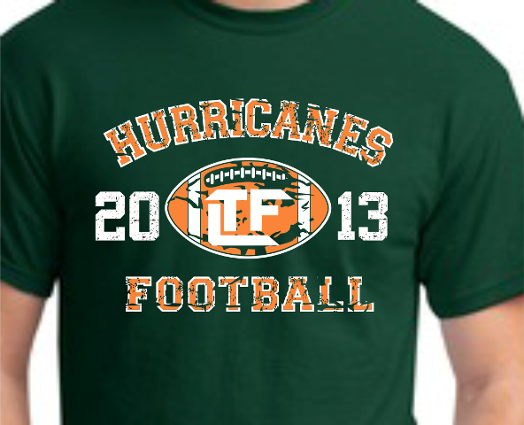 | (S-XL) $15  (2XL-5XL) – add $2.50 | 2013 HURRICANES FOOTBALL - 50/50 Blend Dark Green Tee  - 5.6-ounce, 50 cotton/50 DryBlend poly  - Moisture wicking properties  - Seamless double-needle collar  - Double-needle sleeves and hem  - Taped neck and shoulders
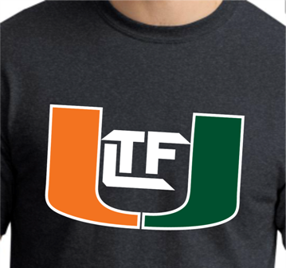 | (S-XL) $15  (2XL-5XL) – add $2.50 | Dark Heather Tee with TFL Hurricanes Logo  - 5.6-ounce, 50 cotton/50 DryBlend poly  - Moisture wicking properties  - Seamless double-needle collar  - Double-needle sleeves and hem  - Taped neck and shoulders
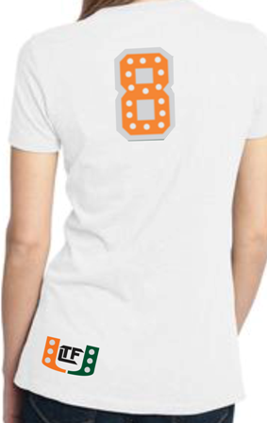 | (S-XL) $45  Price includes (1) 6” digit on back  Add extra digit – 7.50  Add crystals – 10.00  (2XL-3XL) – add $2.00 | Ladies White or Black Tee with CANES 2-color applique on front, TFL Hurricanes applique on back hip, and 6” 2-color number on back. | CANES Applique  __ Small  __ Medium  __ Large  __ XL  __ 2XL (add $2.00)  __3XL (add $2.00)  ____# on back ***(add $7.50 for double-digit)  ___Crystals (add $10)  Subtotal $________
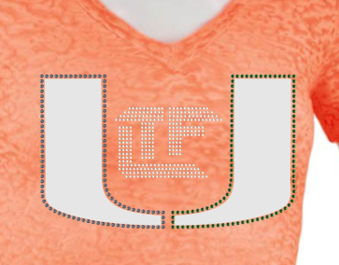 | WBW0110 – (S-XL) $45  (2XL) – add $2.00  Care Instructions:  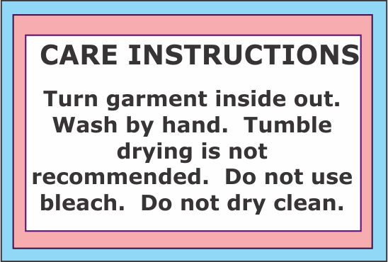 | Women’s Burnout Vintage Wash Twisted V-Neck – TFL Hurricanes Logo with Mirror Silver Foil and Swarovski Crystals – Shirt available in ORANGE or BLACK  Sizes Small 6-8 Medium 10-12 Large 14-16 XLarge 18-20  Bust/Chest 16-1/4" 17-1/2" 19-1/4" 21-3/8"  Front Length HPS 26-1/2" 27-1/2" 28-1/2" 29-1/2"  Bust 35"- 37" 38"- 40" 41"- 43" 44"- 47"  Waist 28"- 30" 31"- 33" 34"- 36" 37"- 40"  Hip 37"- 39" 40"- 42" 43"- 45" 46"- 49"
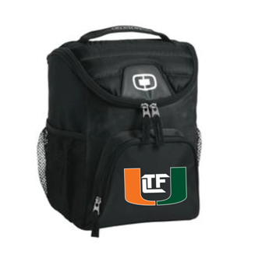  6-12 Can Cooler | $30 | OGIO® - Chill 6-12 Can Cooler – TFL Hurricanes Embroidered Logo  Cooler that serves up 6-12 cans of pure refreshment.  - 600D poly/420D diamond dobby/PEVA lining  - Front zippered pocket  - Dual side beverage/accessory holsters  - Zippered, insulated main compartment holds 6-12 twelve oz. cans  - Easy clean, leak proof lining  - Collapses for storage  - Dimensions: 10.5"h x 8.5"w x 7"d
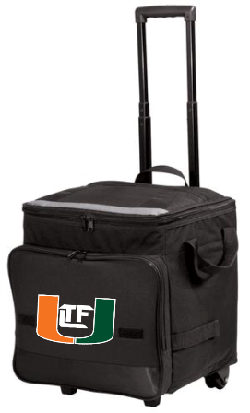  Rolling Cooler | $55.00  Add $6.00 to personalize  Min. of 12 for free S&H | Rolling Cooler – TFL Hurricanes Printed Logo  48-can capacity – Collapsible design makes for easy storage.  - 600 denier polyester, 420 dobby polyester  - Web top and side handles  - Zippered opening  - Easy-to-clean, heat-sealed, water resistant lining  - Removable bottom board  - Zippered front pocket  - One-hand push button extension handle; extends to 21"  - Smooth, durable inline skate wheels  - Dimensions: 14"h x 14"w x 11"d (expanded); 14"h x 14"w x 7"d (collapsed); Approx. 2,156 cubic inches (expanded)
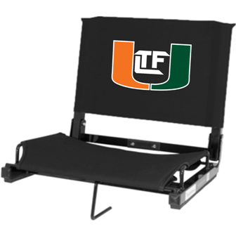  Stadium Chair | SC-1 – $40.00  Add $6.00 to embroider first OR last name  Min. of 6 for free S&H | Stadium Chair – TFL Hurricanes Logo in Tackle Twill  Embroidered First OR Last Name Below Logo – Add $  Durable steel frame construction and tough Cordova canvas make our Stadium Chair the best in any league. Fits virtually any metal or wooden bleacher.  Open: 15.5" x 17"W x 14.5"H  Folded: 15.5" x 17"W x 4"H
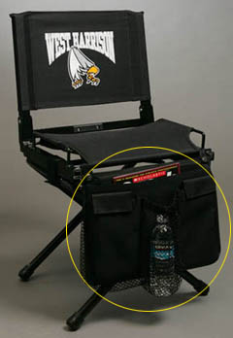 | $18.00 | Stow for Stadium Seat - Blank  Keep personal items from underfoot. StadiumStow has 1 zippered and 2 open pockets to hold water bottles and other belongings. Made of Cordova Canvas to snap to frame of Stadium Chair. Available in black only.
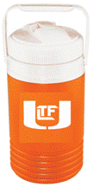 | $16.00/each | Igloo ½ Gallon Beverage Cooler – TFL Hurricanes Logo Imprint  Made in the USA - 1/2 Gallon Beverage Cooler - Comfortable swing handle, screw on lid and pour spout.
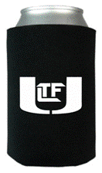 | $4.00/each | Black Koozie – TFL Hurricanes Logo Imprint  • Folds Flat!  • Great Insulation!  • Fits Cans and Bottles

PLAYER NAME___________________________

TEAM/GRADE___________________________________

METHOD OF PAYMENT CASH CHECK#_____

CREDIT CARD INFORMATION

NUMBER
EXP
CCV
ZIPCODE

